V21 - Encryption of Email Body Via Rule - Planning Document

Suggested Design for Implementing within Platform Gov Rules Configuration:

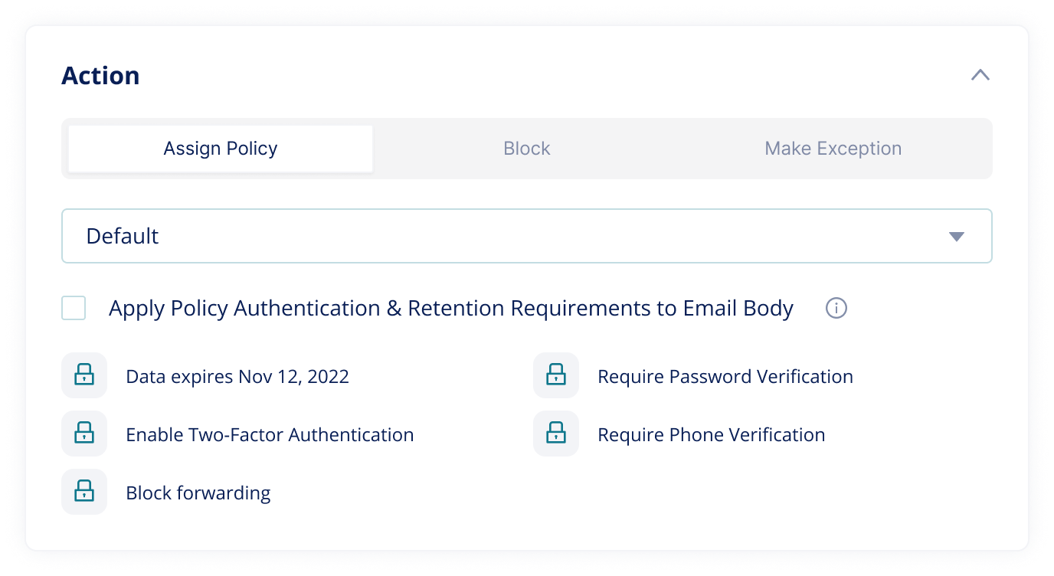
- The check box would apply rule creation that triggers encryption of the email body via the existing Assign Policy – and explicitly call out that only the authentication and retention aspects of the policy applies to the email body.

Questions for discussion:
- We need to explicitly document what happens when a policy assignment rule is applied to the email body as current logic (and connectors) read as if dynamic protection can be applied to the body - AIP, Watermarking, Retention.
  - Actual behavior:
    - Authentication requirements apply to read encrypted message
    - Assumption – retention does apply
    - Watermarking is not supported
    - Forwarding is not supported
    - AIP does not apply
  - If we follow the logic above where differing policy is applied to body vs file, does the higher auth requirement always apply?
    - Meaning, if SMS and email OTP were required to access encrypted email BUT only OTP via email was required to access files, could the user open files after only email OTP was completed?
    - I am also asking this question in regard to mix result for policy assignment within folders

